INTRANET
PROYECTOS ENTREGADOS A NOVIEMBRE 2024
- Video Countdown
- Opening Video
- Modulo Sync Contact Contact
- Website conferencia FUEL
- Website conferencia CCMA
- Website conferencia SAFETY
- Website conferencia LAW
- Website conferencia FORUM
- Control de sponshorships
- Sistema de tareas 1.0
- Gilrs with goals

- Video Countdown

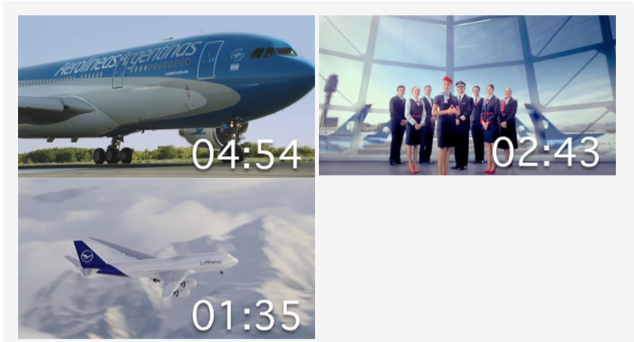

- Opening Video

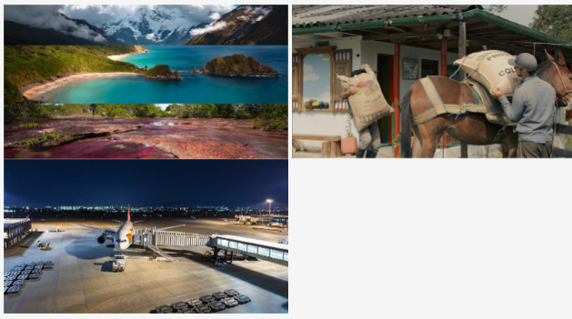

- Modulo Sync Contact Contact
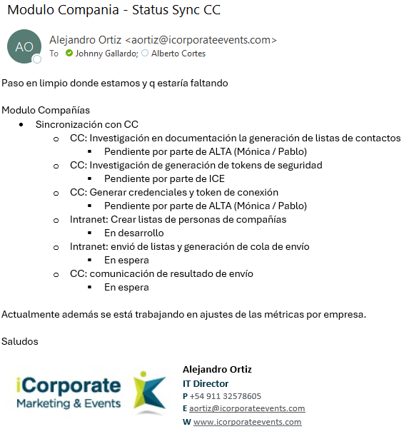

4-5-6-7-8 Website FUEL, CCMA, SAFETY, LAW, FORUM
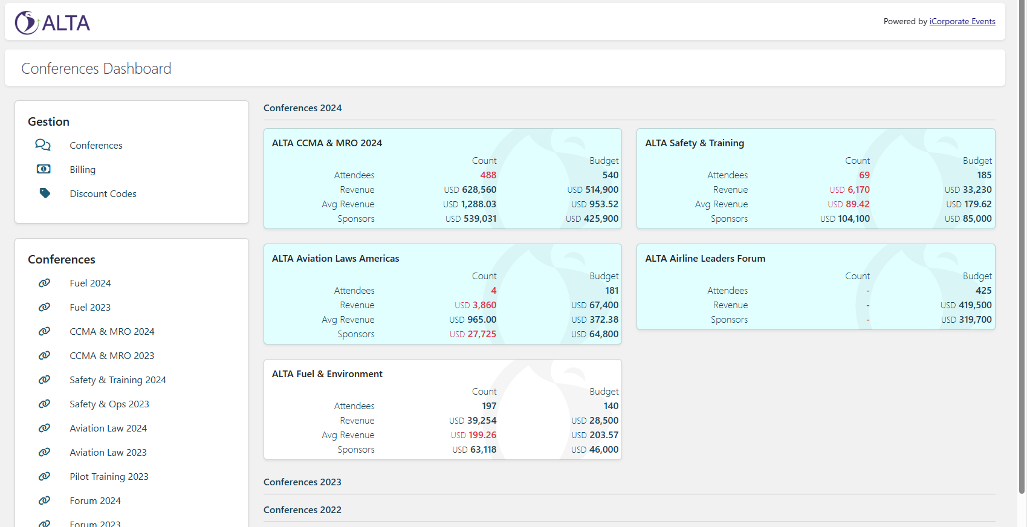

9- Control de sponshorships

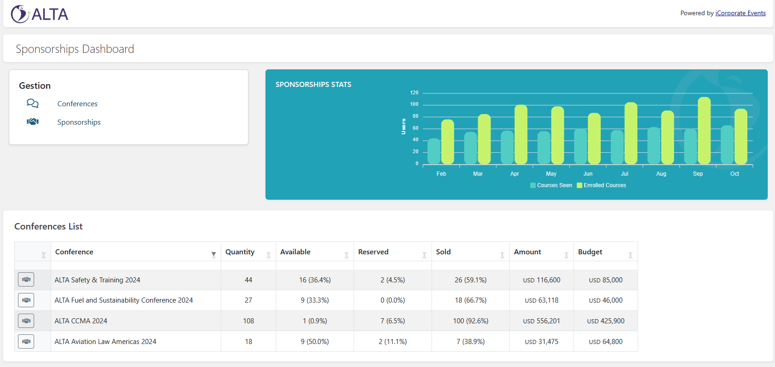

10-Sistema de tareas 1.0

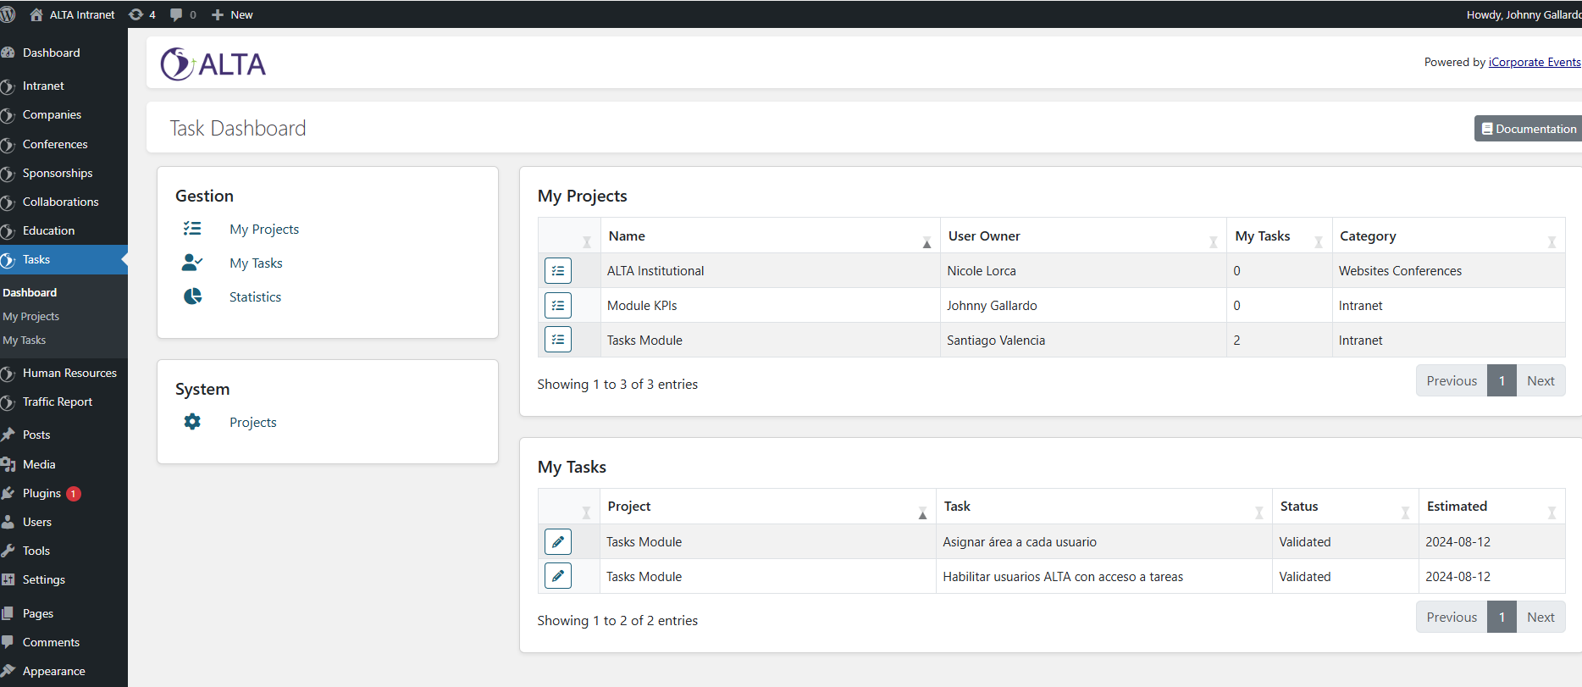

11- Gilrs with goals
