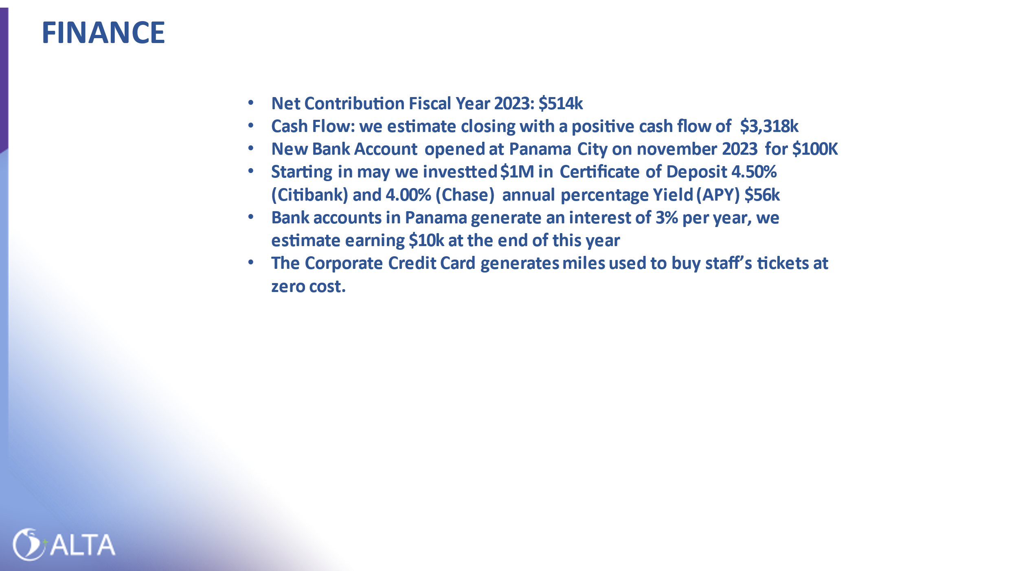

**NET CONTRIBUTION**

|  |  |  |  |  |
| --- | --- | --- | --- | --- |
|  | **2023 Projections** | **Budget 2023** | **2023 Budget vs Projections** |  |
| **REVENUES** | **1,388,449** | **1,410,000** | **(21,551)** |  |
| **EXPENSES** | **1,375,270** | **1,240,440** | **134,830** |  |
| **EVENTS** | **500,531** | **375,887** | **124,644** |  |
| **NET CONTRIBUTIONS** | **513,710** | **545,447** | **(31,737)** |  |

**CASH FLOW**



**CERTIFICATION OF DEPOSIT**

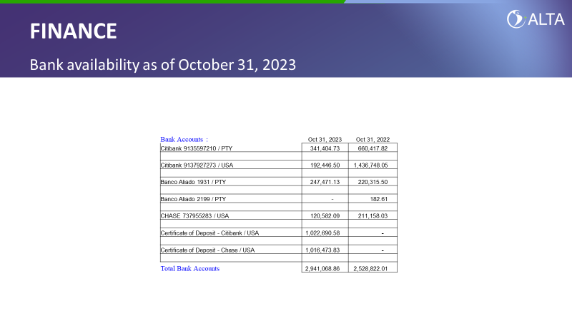

**INTERCOMPANIE**

