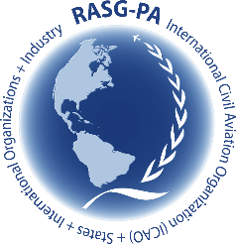

**Regional Aviation Safety Group – Pan America (RASG-PA)**

**65th Meeting – Pan America Regional Aviation Safety Team (PA-RAST/65)**

**Mexico City – 15, 16 & 17 October 2024**

**Tentative Agenda**

**Meeting purpose:**

Review safety information, follow-up on the status of the projects, and progress of CSTs, and define actions and potential projects based on data.

**Before the meeting:**

* Project champions need to be ready to present the status of the projects.
* **Those who present data, please bring the insights that result from that data for better understanding and to facilitate discussion.**

**Agenda:**

**Day 1 – Tuesday, 15 October 2024** (Starts at 09:00)

* Industry Presentations
* Discussion of PA-RAST actions based on Industry presentations
* IATA update on safety matter discussed in past meetings
* Review of past meetings Action Items
* CST Status (Only relevant changes since last meeting)
  + BCAST, CAST, CAG & PCAST
* RASG-PA Safety Partners Program update

**Day 2 – Wednesday, 16 October 2024**

* Project Status Review
  + CFIT
  + LOC-I
  + MAC
  + Runway Safety
  + Turbulence video
  + Translation Project
* Discussion on potential new projects
* Safety data Review
  + FDX
  + ASIAS
* GTE Data: Safety risk factors in CAR/SAM RVSM (GTE presentation)
* Discussion of PA-RAST actions based on Data Review

**Day 3 – Thursday, 17 October 2024** (Ends at Noon)

* RASG-PA Safety Day 2024 update
* RASG-PA Annual Safety Report review
* 2025 Outlook for PA-RAST
* Review of new Action Items
* AOB

**Main expected outcomes:**

* Awareness on the status of the projects
* Agreement on next steps for each project
* Agreement on actions items status

---------