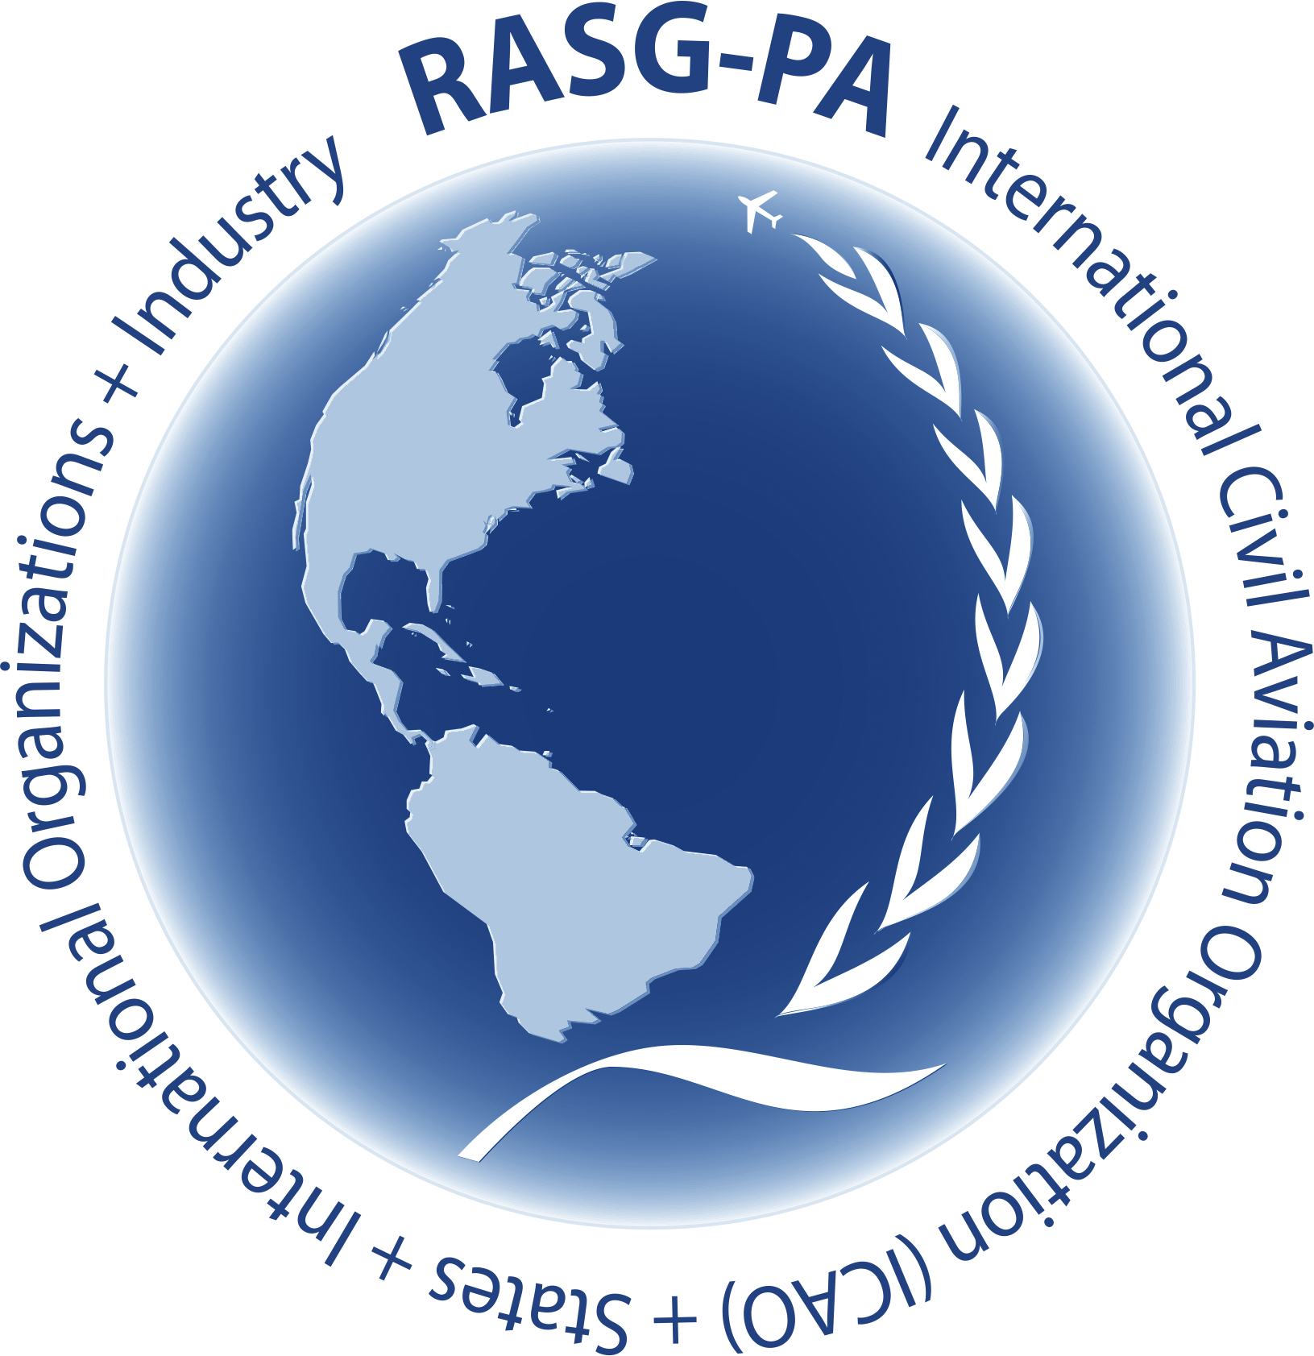**RASG-PA SAFETY ADVISORY**

**RSA-XX**

**xx November 2024**

**Regional Aviation Safety Group – Pan America (RASG-PA)**

**RUNWAY EXCURSION – VEER OFF**

|  |  |
| --- | --- |
| **Document Abstract and Target Audience** | This safety advisory identifies key contributing factors in recent Veer off incidents and proposes a series of 20 recommendations intended to reduce the risk of Runway excursion veer off events. The content is based on analysis performed by the Brazilian Commercial Aviation Safety Team (BCAST) and is recommended for consideration of other regions in the Americas.  This RSA has recommendations addressed to:  -Aircraft Operators,  -Aerodrome Operators,  -Air Navigation Service Providers (ANSPs); and,  -Civil Aviation Authorities (CAAs). |
| **Occurrence Category** | Runway Excursion (RE) with emphasis on Veer Off. |
| **Issue Summary** | The Brazilian Commercial Aviation Safety Team (BCAST) observed a rise in precursor events contributing to recent veer off incidents in Brazil. Although industry has made considerable progress in mitigating the risk of runway excursions over the past few decades, the primary focus has been on factors leading to longitudinal runway excursions (Runway Overruns).  The increasing trend of veer off events highlights the need for increased engagement from various industry stakeholders to address the factors contributing to lateral runway excursions (veer offs). |
| **Key Recommendations** | **Aircraft Operators**: Update their operational manuals and training programs.  **Aerodrome Operators**: Ensure the operability/accuracy of the various equipment necessary for the precise information on wind direction and speed.  **ANSPs**: Establish processes that ensure the rapid delivery of essential and up-to-date information regarding aerodrome conditions, such as adverse weather factors, wind, and runway surface conditions, with emphasis on situations where these conditions deteriorate quickly.  **CAAs**: Incorporate modifications to the current Standards and Regulations to facilitate and/or promote the harmonization of the application of mitigation strategies for the identified scenarios. |

1. **Purpose**

This RASG-PA Safety Advisory (RSA) provides targeted recommendations to help prevent veer off occurrences.

1. **Background**

During discussions within the Brazilian Commercial Aviation Safety Team (BCAST), an increase in precursor events related to veer offs was identified, contributing to the recent occurrence of some incidents in Brazil. It is understood that the contributing factors identified in Brazil could be valuable for other regions across the Americas.

Over the past decades, significant progress has been made in the industry on this topic, but the focus has primarily been on factors contributing to longitudinal runway excursions (Runway Overrun). This reinforces the current need for greater involvement from various industry stakeholders in addressing the contributing factors for veer offs.

In the latest edition of the Global Action Plan for the Prevention of Runway Excursions (GAPPRE, Parts 1 and 2), a document produced by the Flight Safety Foundation (FSF) and Eurocontrol and validated by ACI, EASA, IATA, and other institutions, the topic is thoroughly addressed. Issues such as the absence of center line lighting, crosswinds, adverse weather conditions, and operations with maintenance operational limitations (items on ACR) are identified as contributing factors. The document also offers several recommendations aimed at establishing robust preventive and recovery barriers to address undesired situations. These include the implementation of training focused on recovery barriers (e.g., low-altitude go-arounds, rejected landings, etc.) as well as technological barriers (such as the installation of ATIS – D-ATIS systems, automated wind direction and intensity measurement systems, etc.).

There is a continuous effort by Aircraft Operators, Aerodrome Operators, ANSPs, and regulatory bodies to adopt the best industry practices. Therefore, the main objective of this RSA is to highlight the current key challenges related to the topic across the most diverse operational realities worldwide, and to recommend the adoption or adaptation of these best practices, with the aim of enhancing aviation safety in the Pan-American region.

1. **Hazard Statement**

This RSA is focused on the risk of runway excursion veer offs. A runway veer off is an excursion in which an aircraft departs the physical edges of a runway/taxiway, during takeoff, landing, or line-up. A veer off can occur as a result of a variety of contributing factors (e.g. ineffective communication of runway conditions, visibility/weather/wind conditions, airport design and runway lighting and markings, pilot decision making and training, system component failure, etc) that can lead to surface misalignment and/or loss of directional control resulting in a lateral runway excursion. The consequences of Runway veer offs can include loss of life, property damage, runway closure, airport closure, flight diversion, legal issues, inconvenience to passengers, loss of revenue for airlines.

Analyzing the contributing factors of recent Brazilian occurrences related to this issue, the following stand out as the most significant:

* **Sudden visibility deterioration** due to the worsening of pre-existing meteorological phenomena (e.g., heavy rainfall);
* **Limited infrastructure resources** at Brazilian aerodromes/airports (e.g., absence of Runway Center Line Lights (RCLL) and Precision Approach Path Indicator (PAPI);
* **Lack of assertive communication** during rapidly deteriorating weather conditions from air traffic control service providers (e.g., control towers, AFIS, etc.);
* **Events related to** **human factors**, such as: "Tunnel Vision" (a narrowing of vision or diminished awareness of peripheral factors), "Spatial Disorientation" (due to visual impairment), and "Landing Compulsion" (a mission-oriented mindset that overrides the assessment of present threats and risk factors).

1. **Safety Analysis Summary**

Flight Safety Foundation’s Aviation Safety Network (ASN) database shows there were five runway excursion accidents involving airliners in 2023.

Runway excursions occur frequently, but usually are not fatal.

Since 2018, 82 percent of the 97 excursion accidents in the ASN database occurred during landing, with more veer offs than overruns. Unstable approaches and failure to go around were the most common contributing factors.

The International Air Transport Association (IATA) Interactive Safety Report, filtered for the LATAM/CAR and NAM regions, shows that over the past 10 years, there were 31 accidents, 3 of which were fatal. Of these 31 accidents, 19 were veer offs, representing 67% of the total.

Source: <https://www.iata.org/en/publications/safety-report/interactive-safety-report/>

1. **Recommendations**
2. Aircraft Operators
3. Incorporate into theoretical and practical training programs the concepts of Runway Excursion – Veer off, as well as all recovery maneuvers to be trained, with clear and objective guidance. This should aim to closely replicate scenarios from recent industry incidents (e.g., nighttime operations, absence of centerline lighting, sudden visibility deterioration, heavy rainfall, communication failure with control authorities, etc.);
4. Clearly include in operational manuals the concepts of Runway Excursion – Veer off, as well as all related operational policies adopted to mitigate this risk (e.g., crosswind limits, exclusive operation by the captain, prohibition of operations during heavy rain, mandatory go-arounds during deteriorating weather conditions, etc.);
5. Incorporate into approach briefing policies details about runway characteristics, especially in locations that pose particular challenges related to the topic (e.g., noting crosswind components, approach and landing techniques on narrower-than-usual runways, executing a rejected landing in the event of degrading VMC conditions, etc.);
6. Develop precursor event algorithms for Runway Excursion – Veer off risk and monitor trends in your Flight Data Monitoring (FDM) programs, considering any data recording limitations;
7. Address in-depth during initial and recurrent crew training the Human Factors most common in this type of incident: Tunnel Vision, Spatial Disorientation, and Landing Compulsion. Focus on these concepts, recognition of the situation, and possible mitigation and recovery actions to avoid undesired outcomes;
8. Emphasize the rejected landing maneuver during training, aiming to reduce pilots' compulsion to land and their tunnel vision during degraded weather conditions.
9. Aerodrome Operators
10. Consider the installation and operation of an automatic transmission system for updated meteorological information (ATIS);
11. Consider the installation of Runway Center Line Lights (RCLL);
12. If installed, runway centerline lights (RCLL) should be used together with edge lights whenever they are illuminated and when the runway is in use;
13. Ensure the proper installation of wind direction and speed indicators in the most suitable locations to provide the best possible indication of conditions along the runway and touchdown zones, in accordance with ICAO and ANAC standards.
14. Air Navigation Service Providers
15. Create processes to ensure the rapid dissemination of essential and updated information regarding aerodrome conditions, such as adverse weather factors, wind, and runway surface conditions, with particular emphasis on situations involving the rapid deterioration of these conditions;
16. Provide pilots with clear, timely, accurate, and updated transmissions of meteorological information for the aerodrome, especially during rapidly deteriorating weather conditions, regardless of the type of operation;
17. Maintain the integrity of the essential information supply chain from the originator (e.g., Met Office/aerodrome operator) to the user (e.g., flight crews, ATS, Met Office, aerodrome operator, and AIS provider);
18. Conduct regular training routines on the use of ATIS/D-ATIS for your staff;
19. Utilize and maintain compliance with the ICAO Global Reporting Format (GRF) for the assessment and timely reporting of runway surface conditions, ensuring that all relevant personnel receive proper training.
20. Civil Aviation Authorities

These recommendations were drawn from the analysis of Brazilian regulations. Therefore, other CAAs should assess their applicability to their local context.

It is recommended that CAAs assess the following regulatory issues and determine how to incorporate any necessary changes to the standards and regulations related to the prevention of Runway Excursion – Veer off, as recommended by this RSA and outlined below:

1. Incorporate concepts and training items related to Runway Excursion – Veer off into the minimum required content list for operational manuals and training programs mandated for air operators;
2. Increase the requirements for minimum necessary resources, including but not limited to runway centerline lighting (RCLL), edge lighting, lateral markings and signage for Precision Pathway Designators (PPD), and other relevant technological barriers available in the market aimed at mitigating the risk of veer offs. These should be included in the certification/recertification requirements for both public and private aerodrome operators;
3. Reduce the timeframe for compliance with mandatory regulatory items that are still pending (e.g., insufficient infrastructure, inoperative equipment/systems, operations without wind direction and speed indicators, etc.), to expedite the process of adaptation for public and private aerodrome operators;
4. Include an analysis of the braking index for runways, comparing the right and left sides of each section measured, as large differences in friction coefficients could cause aircraft to drift off their centerline;
5. Assess opportunities for improvement in the more effective implementation of the ICAO Global Reporting Format (GRF), including:

* Adapting the GRF to local precipitation conditions;
* Encouraging the use of GRF by both aircraft and aerodrome operators.

1. Other comments

Due to the potential challenges mentioned below, each stakeholder may propose alternative ways to meet the recommendations of this RSA, considering the performance characteristics and specific limitations of their infrastructure, as well as adjustments to their operational and training standards.

* Increasing use of airports that were previously not commercially utilized by larger aircraft, with limitations in terms of infrastructure (e.g., runways with reduced dimensions – length and width, deteriorating pavement, absence or inoperability of lighting aids, poor signage, etc.);
* A wide variety of new concessionary companies operating and managing current Brazilian aerodromes/airports;
* Limited infrastructure in terms of air navigation services and air traffic control at airports considered regional (e.g., absence of control towers, limitations in essential meteorological data measurement resources, limited human resources, among others).

1. **References**

* IATA Annual Safety Report, available at <https://www.iata.org/en/publications/safety-report/>
* Flight Safety Foundation’s 2023 Safety Report, available at <https://flightsafety.org/foundations-annual-report-highlights-threat-to-aviation-safety-from-eroding-safety-culture/>
* Global Action Plan for the Prevention of Runway Excursions (GAPPRE), available at <https://flightsafety.org/toolkits-resources/gappre/>
* RMK: By the time this RSA was finalized, the BCAST Safety Enhancement – Veer off had not yet been published in Brazil. This is expected to happen in the coming weeks.

— END —